**Name – Tanishq Thuse**

**Branch – CSAI**

**Div – B**

**Roll no. – 52**

**Subject – Computer Network**

**Assignment – 1 : Setting up small wired computer network : Set up a small wired network of 2 to 4 computers using Hub/Switch/. It includes Preparation of Cables and setting up wired network.**

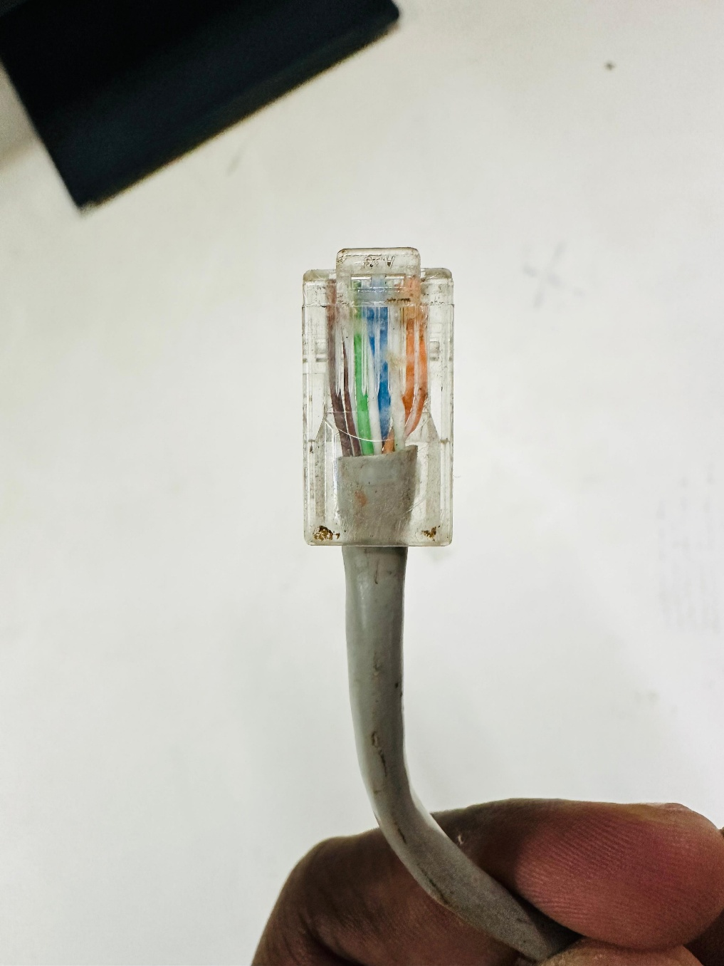

**Lab: Preparation of Ethernet Cable for Wired Network**

**Objective**

To prepare a straight-through Ethernet cable using CAT5e cable and RJ-45 connectors following the T568B wiring standard.

**Materials Required**

* CAT5e cable (unshielded twisted pair – UTP)
* RJ-45 connectors (8-pin)
* Crimping tool
* Cable stripper or cutter
* Cable tester (optional)

**Theory**

Ethernet cables use twisted pairs of wires to transmit and receive data.  
For connections between computers and network devices (hub, switch, router), a **straight-through cable** is used.  
In a straight-through cable, both ends have the same wiring order. The most commonly used wiring scheme is **T568B**.

**T568B Wiring Order**

Pin numbers (1–8 from left to right with clip facing away from you):

1. **White-Orange**
2. **Orange**
3. **White-Green**
4. **Blue**
5. **White-Blue**
6. **Green**
7. **White-Brown**
8. **Brown**
9. 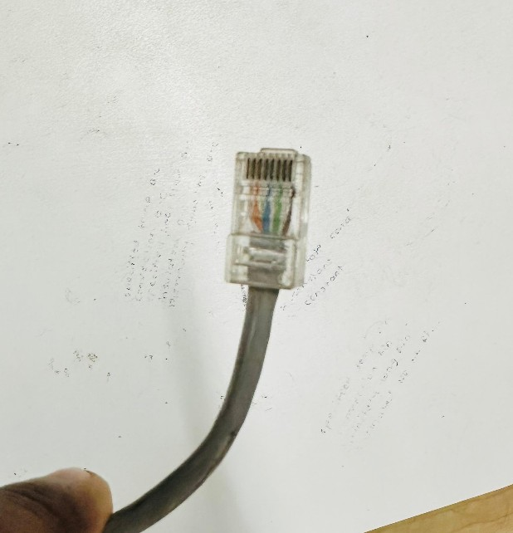

**Procedure**

1. **Measure and Cut**
   * Measure the cable to the required length and cut it using the cutter.
2. **Strip the Outer Jacket**
   * Remove about 2.5 cm (1 inch) of the outer jacket without damaging the inner wires.
3. **Untwist and Arrange Wires**
   * Untwist the four pairs and arrange them in the **T568B** order.
4. **Trim Wires Evenly**
   * Cut the wires so they are all the same length.
5. **Insert into RJ-45 Connector**
   * Hold the connector with the clip facing down, insert wires carefully in the correct order.
6. **Crimp the Connector**
   * Place the connector into the crimping tool and press firmly to lock wires in place.
   * 
7. **Repeat for the Other End**
   * Follow the same T568B order for the other connector.
8. **Test the Cable** *(optional)*
   * Use a cable tester to verify correct wiring and continuity.

**Observation**

The cable was prepared with the correct T568B wiring sequence on both ends. The pairs were neatly arranged, and the crimping was secure.

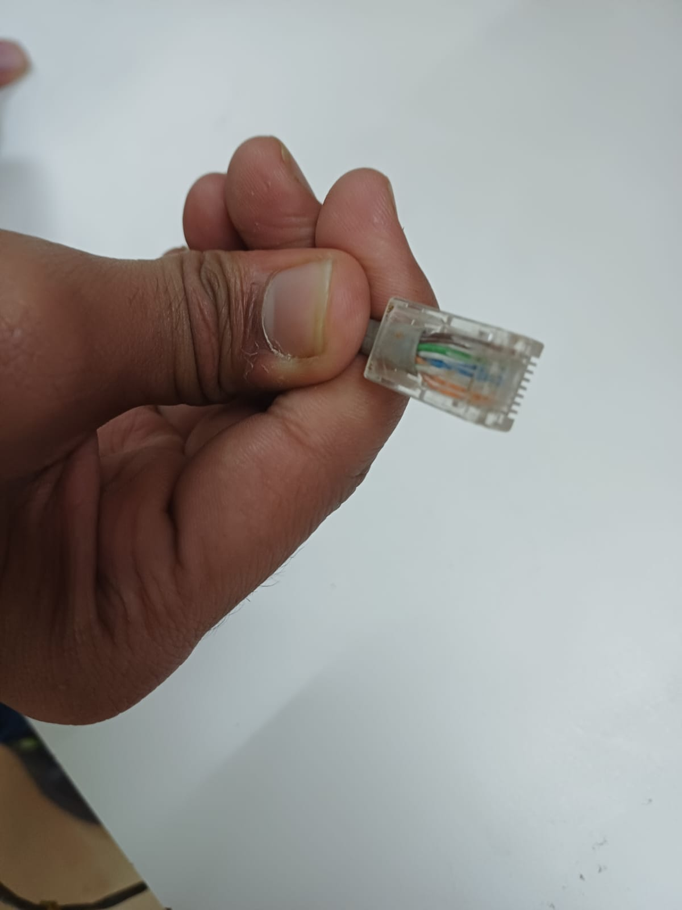

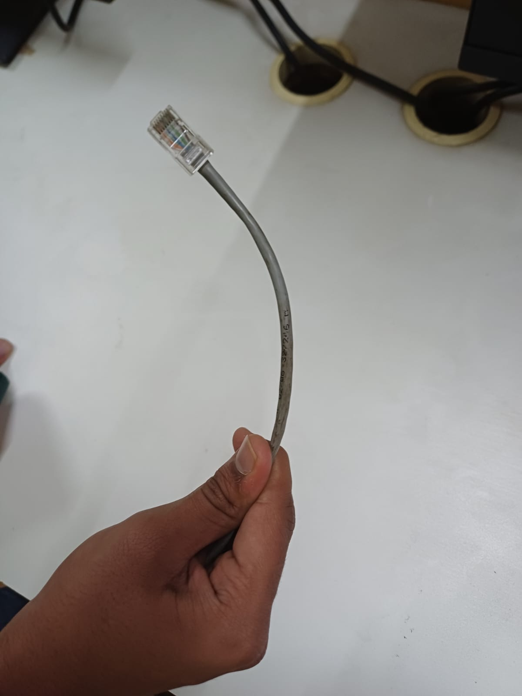

**Conclusion**

Following the correct color coding standard ensures proper connectivity in wired networks.  
A well-crimped Ethernet cable reduces data loss and increases reliability.